**Mean Square Error (MSE)**

. MSC tell you how close regression line is to set of points it does this by taking distances from those points to the regression line, those distance are call errors. And those errors are squared to remove any negative signs the embassy also gives more weight to larger differences, and it’s called the mean squared error because we’re finding the average of a set of errors

. The lower embassy the better the forecast. MSC formular: n is number items sample; multiplied by sigma

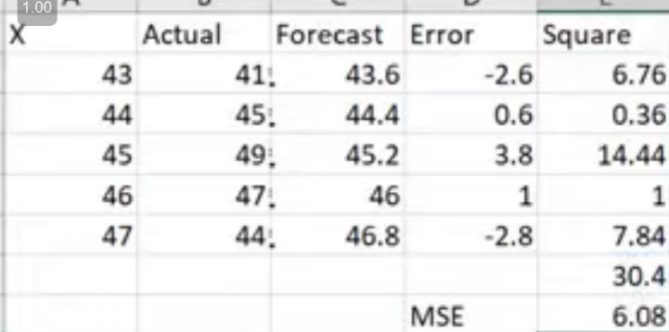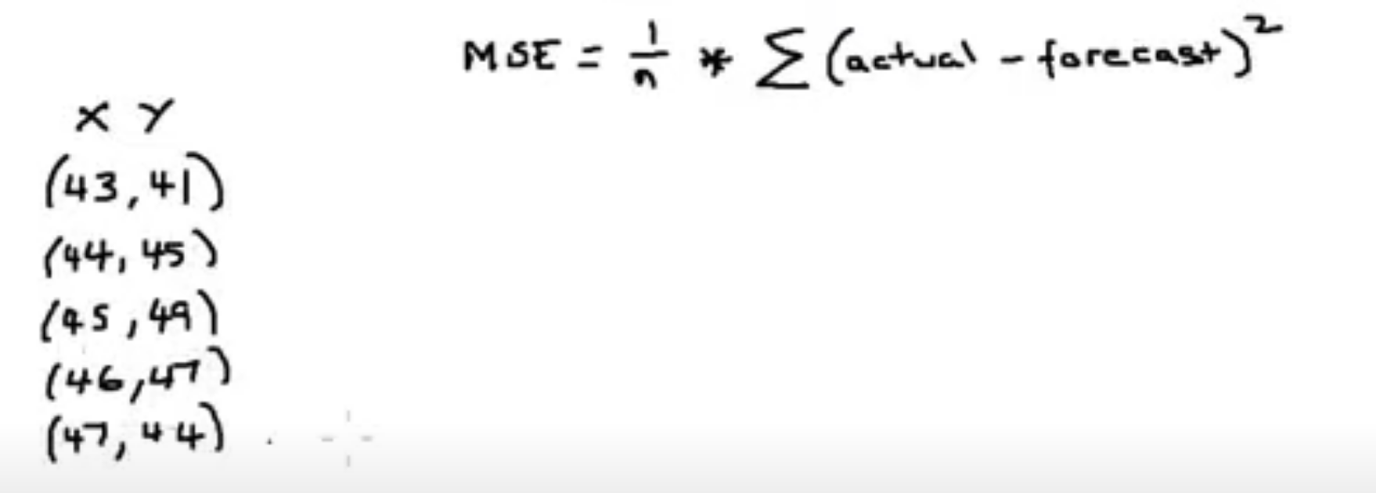

**Linear Regression**

The main ideas:

. Use the least – square to fit a line to the data.

. Calculate R2

. Calculate a p-value for R2.

Do quick review Use the least – square to fit a line to the data.

Talk about the data set about a bunch of mice. That we measure the size, and their weight. Our Goal is to use mouse weight as a way to predict mouse size

First draw a line through the data

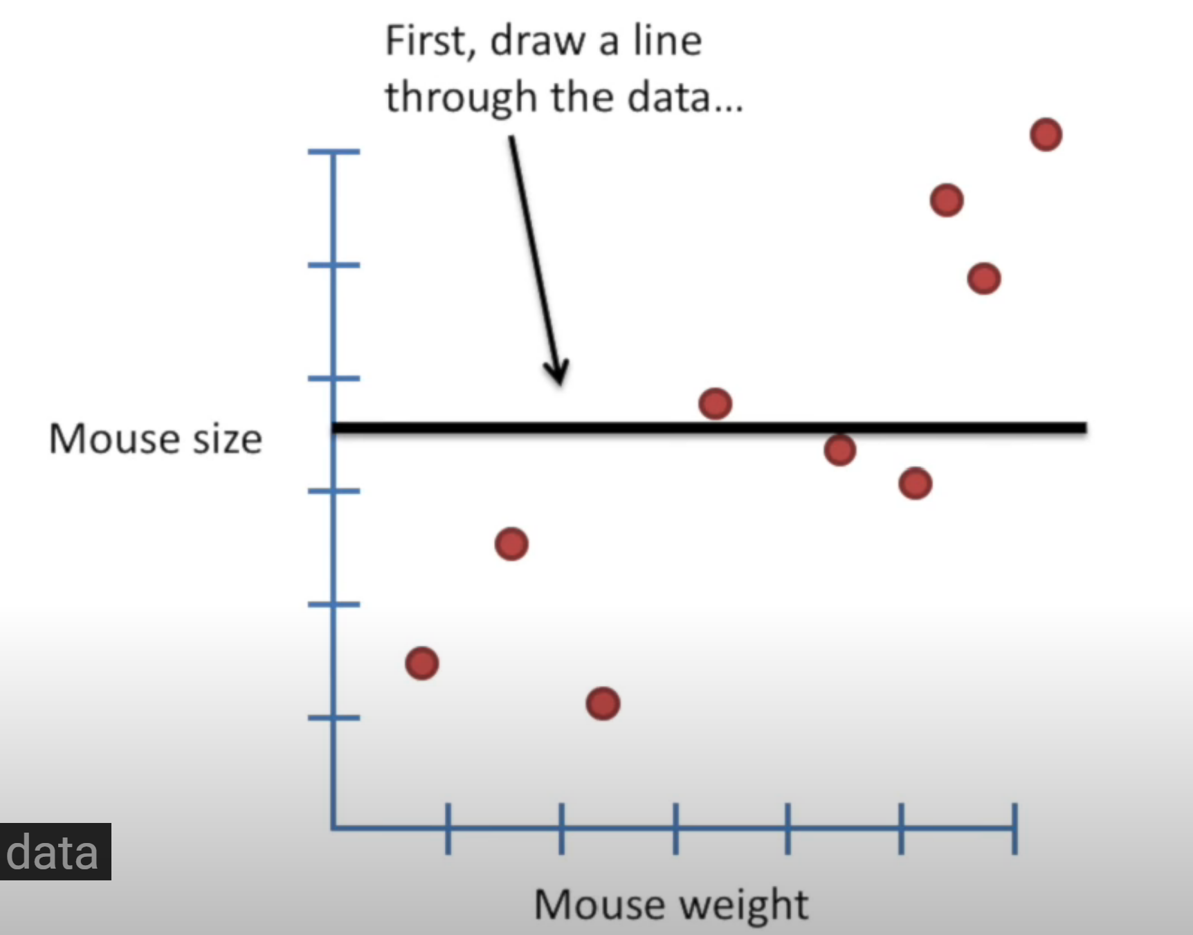

Second measure the distance from the line to the data, square each distance and then add them up.

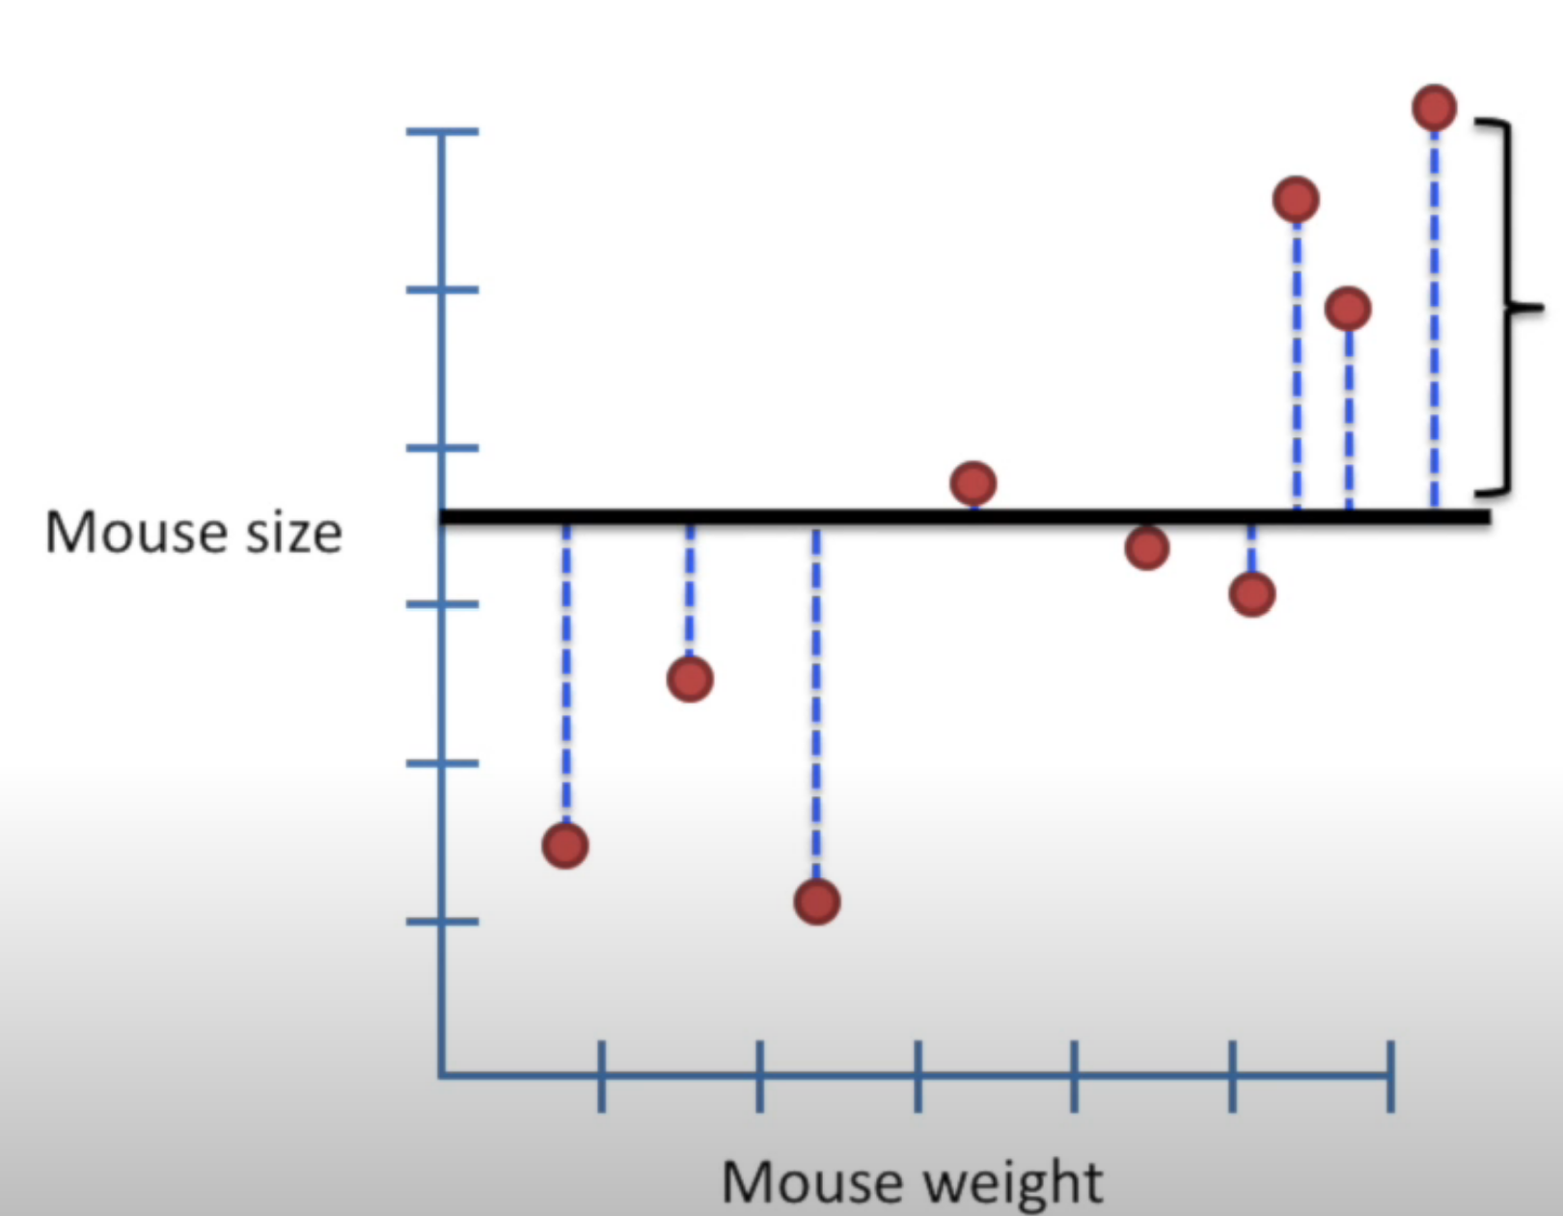

Terminology: The distance from a line to a data point is called a **“residual”**

Thirst, rotate the line a little bit

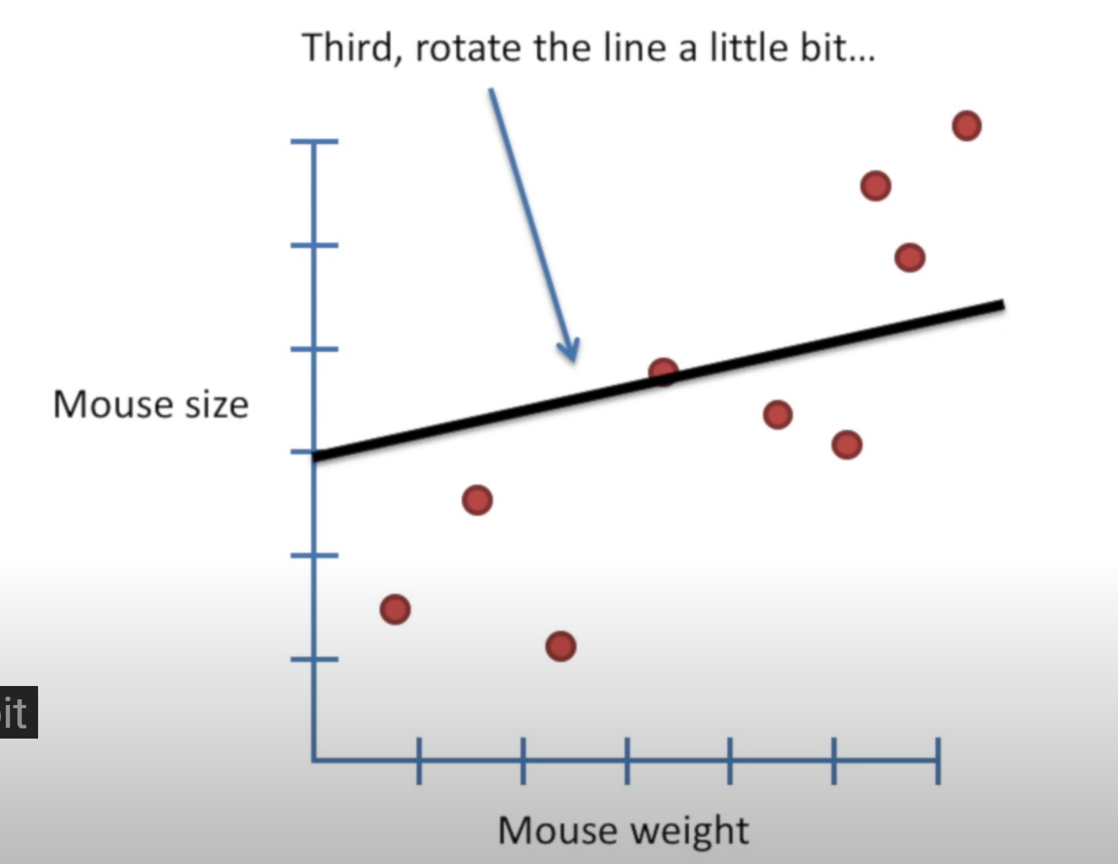

With the new line measure the residuals, square them, and then sum up the squares.

Now, rotate the line a little bit more. Sum up the square residuals

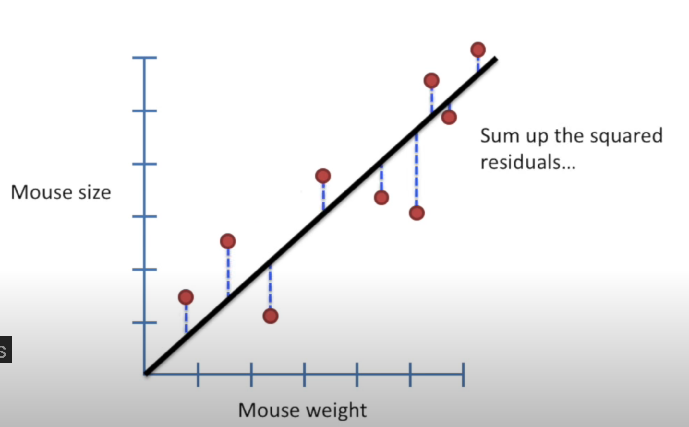

After a bunch of rotations, you can plot the sum of squared residuals and corresponding rotation.

Now, we have the sum of the square residual on the y-axis and the rotation on the x-Axis. Then find the rotation that has least sum of squares. **Use the least – square to fit a line to the data**.

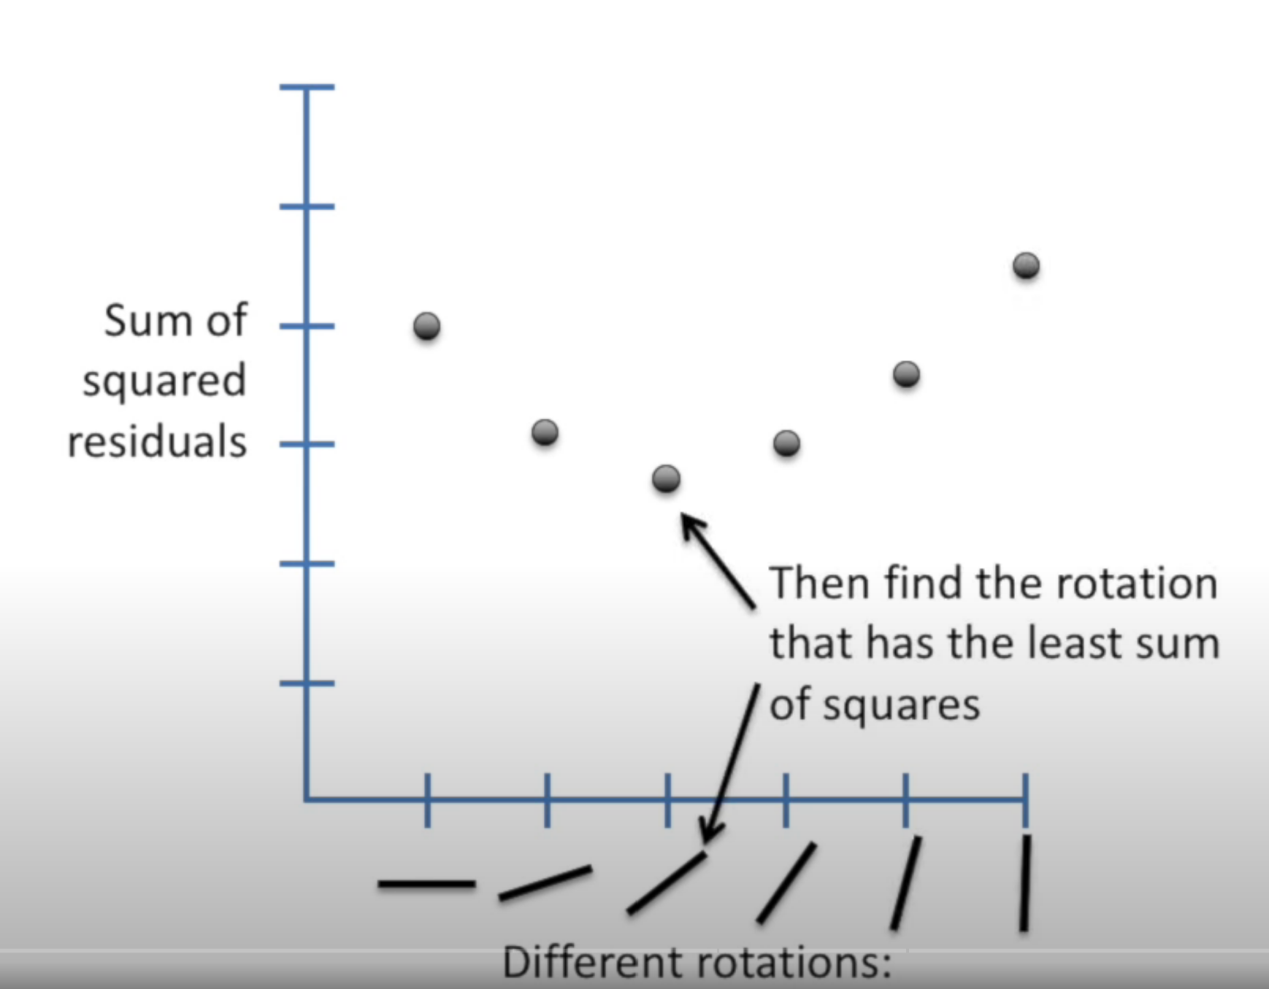

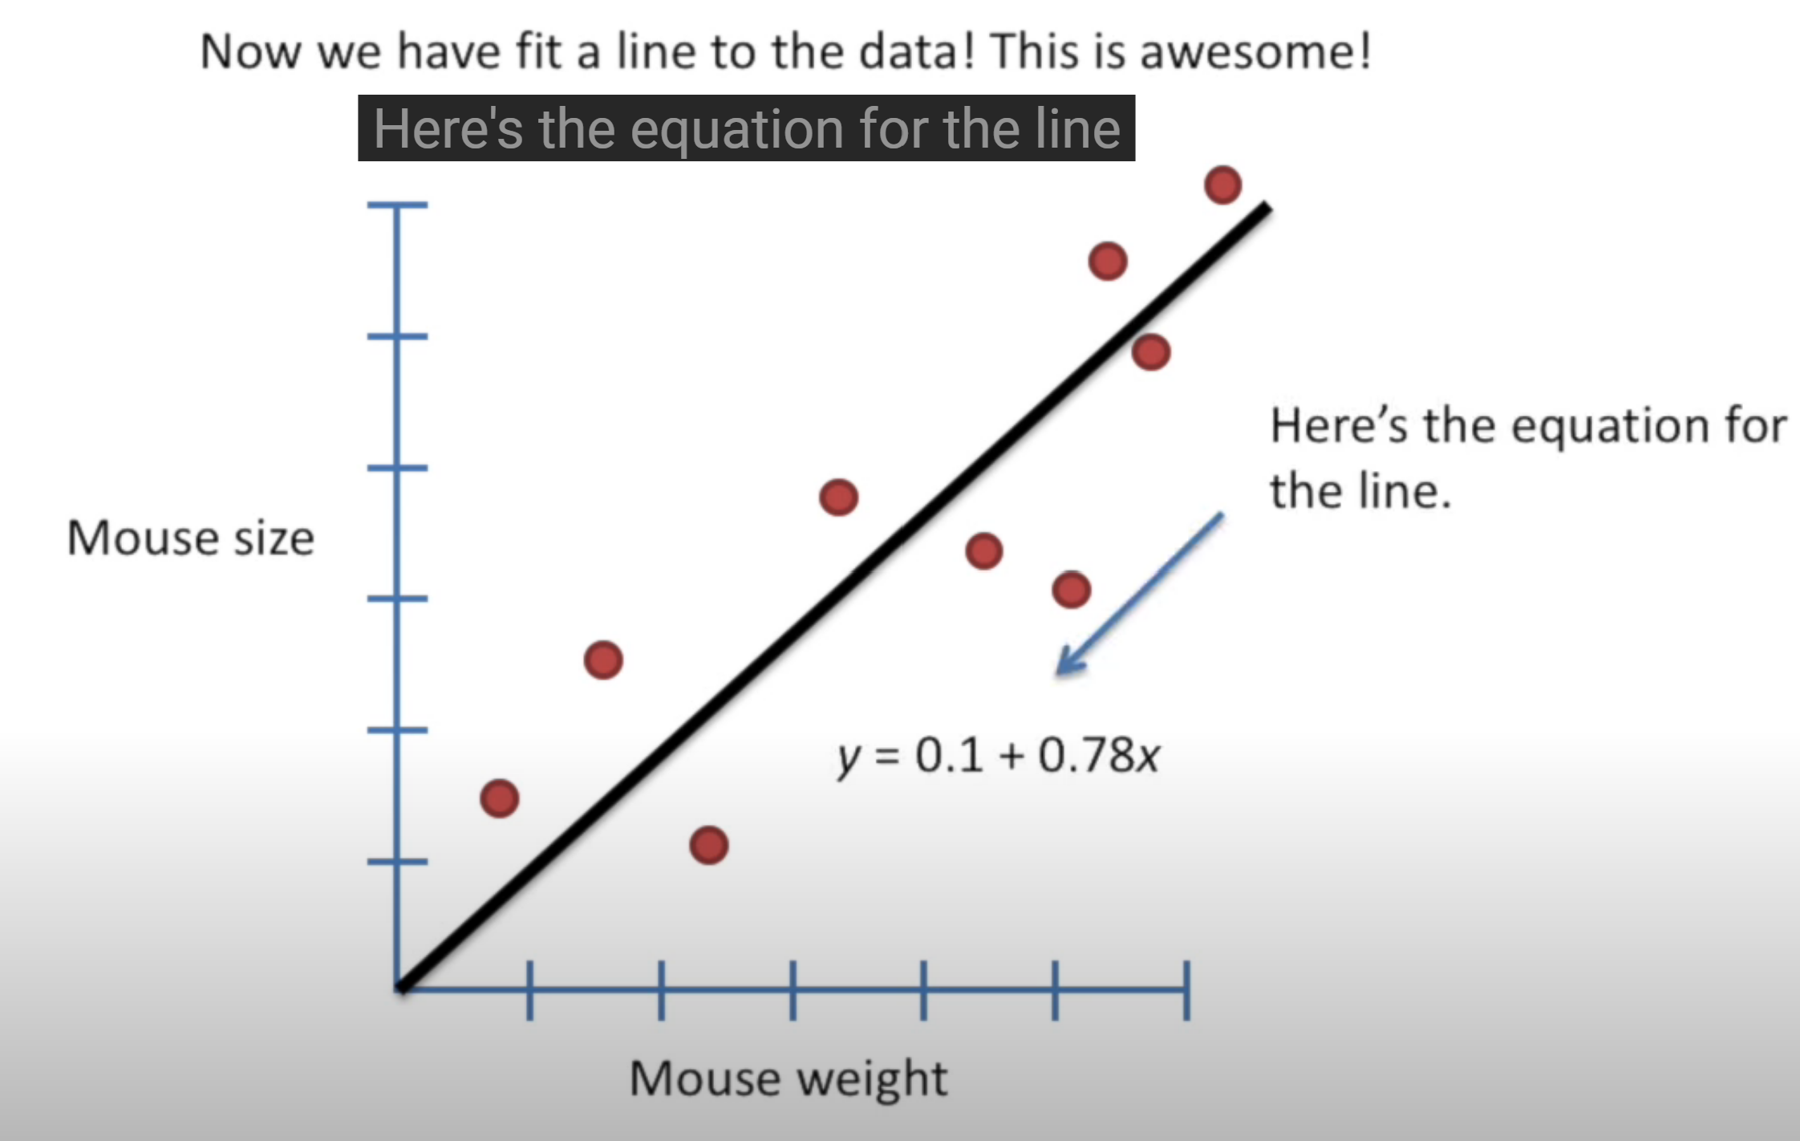

Least-square estimate 2 parameters: y = 0.1 + 0.78x. Y-axis intercept and the slope, since the slope is not 0, it means that knowing a mouse’s weight will help us a guess about that mouse’s size.

Calculate R2 is the first step in determining how good that guess will be.

**First** calculate the average mouse size

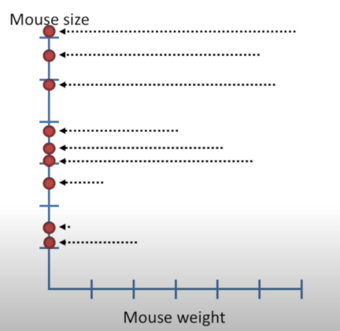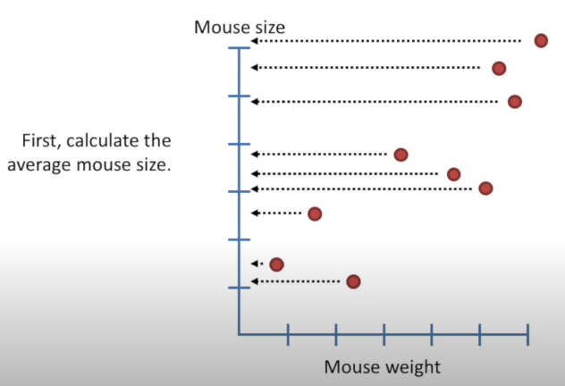

Here we have shifted all of the data point to the y-Axis to emphasize that, at this point, we are only interested in mouse size.

Here draw a black line to show the average mouse size.

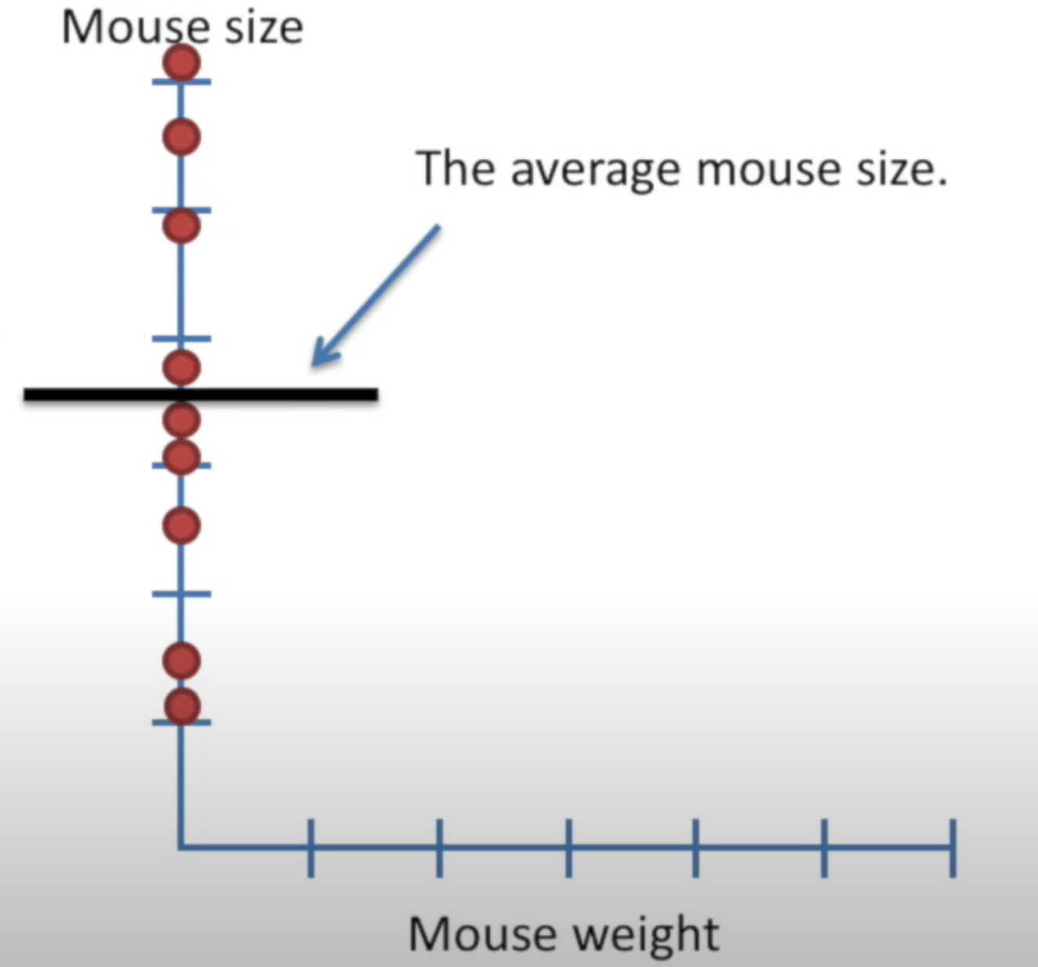

Now sum the square residuals.

Just like in least square, we measure the distance from the mean to the data point and square it then add those squares together.

Terminology: we ‘ll call this **SS(mean)** for “Sum of squares around the mean”

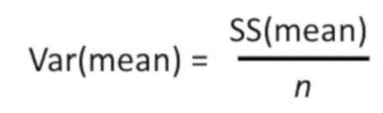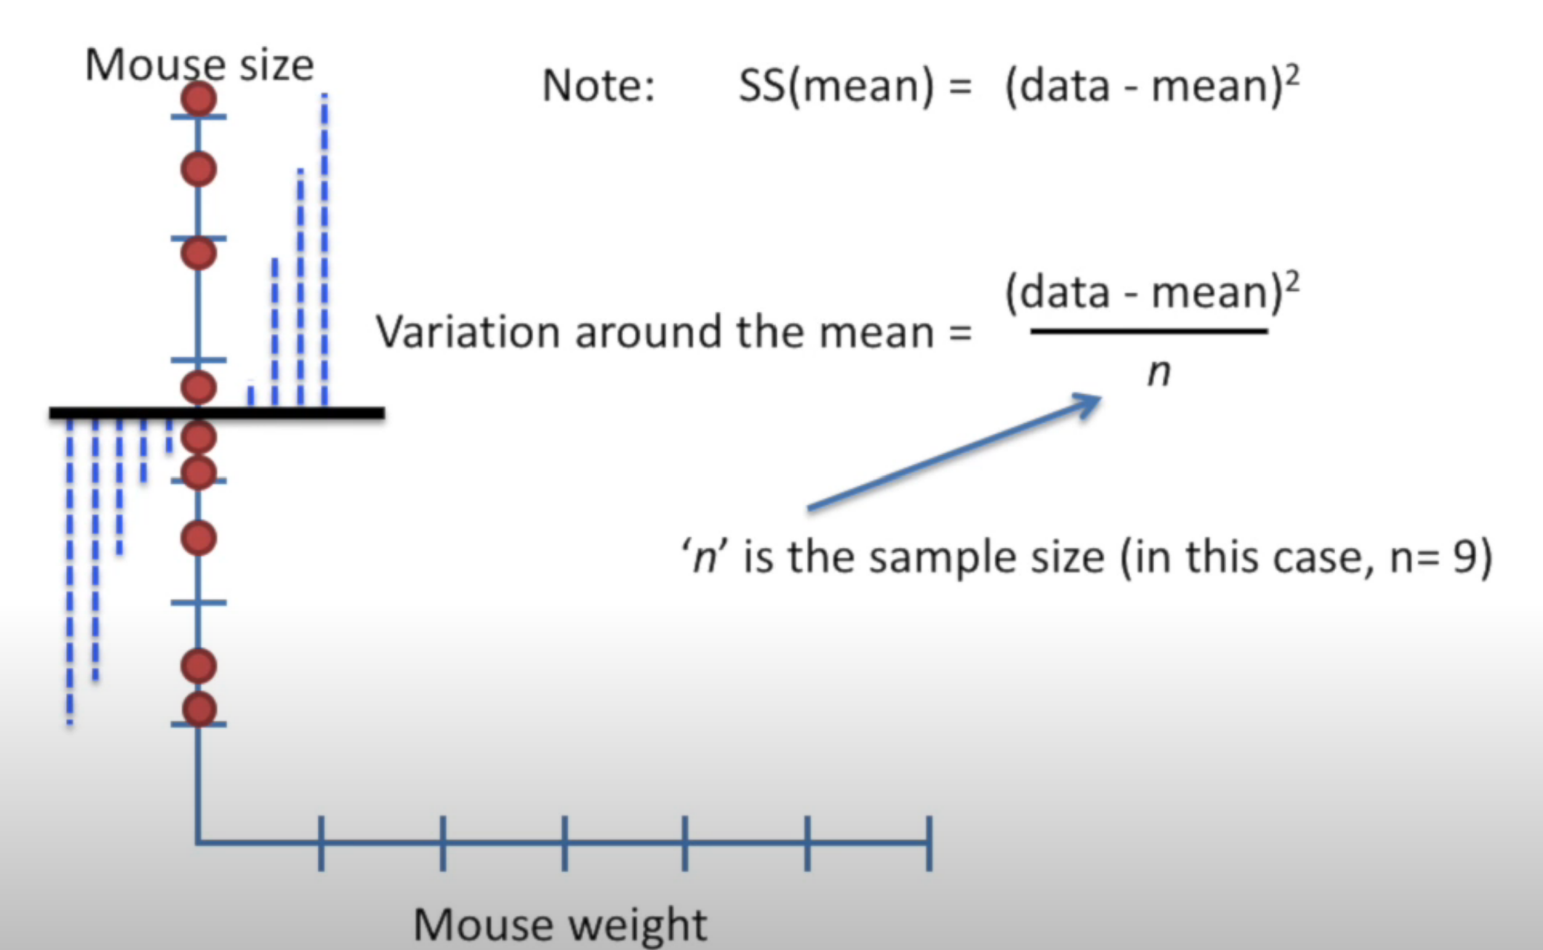

Another way to think about variance is as the average of squares per mouse.

Now go back to original plot.

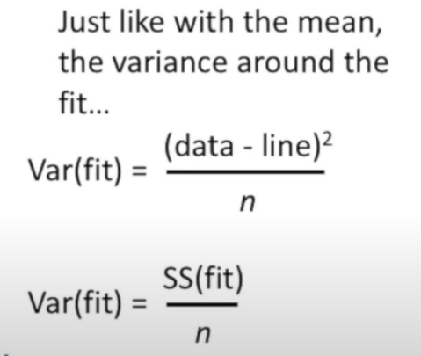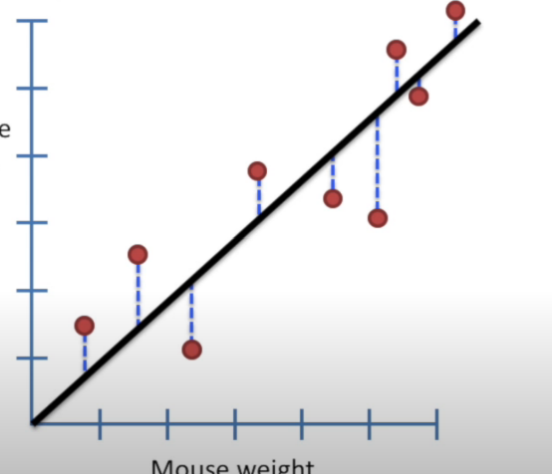we’ll call this SS(fit), for the sum of square around the least-squares fit.

SS(fit) = (data - line)2.

Again, we can think of Var(fit) as the average SS(fit) for each mouse.

R2 tell us how much of the variation in mouse size can be explained by taking mouse weigh into account.

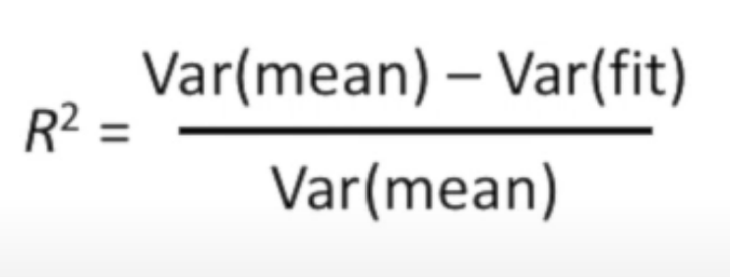

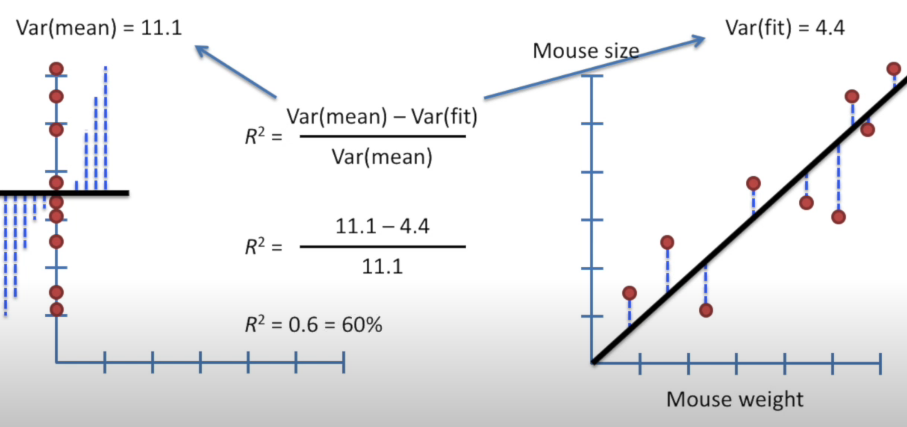

This mean. There are a 60% reduction in variance when we take the mouse weight into account.

Alternatively, we can say that mouse weight “explains” 60% of the variation in mouse size.

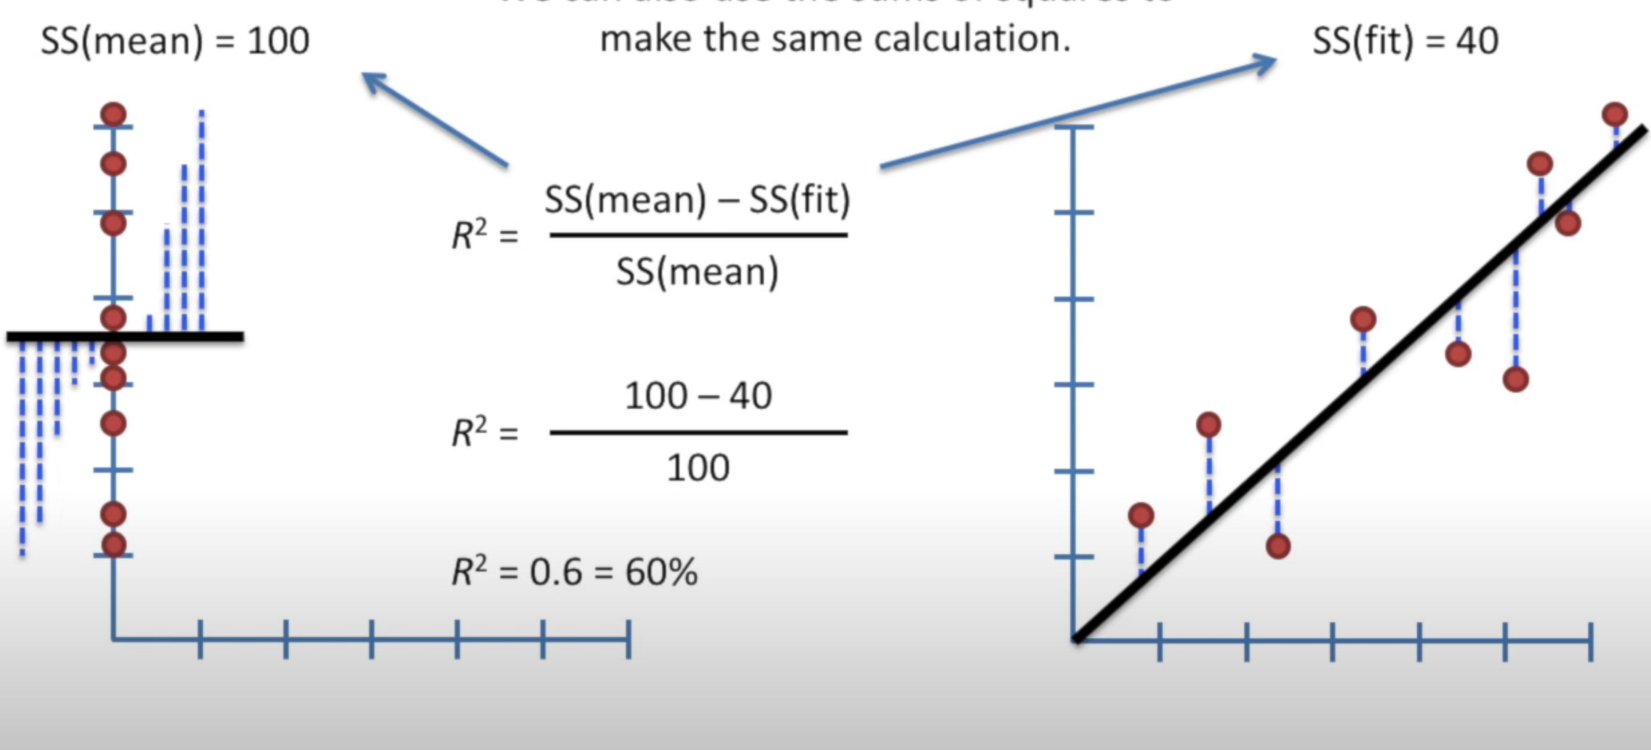

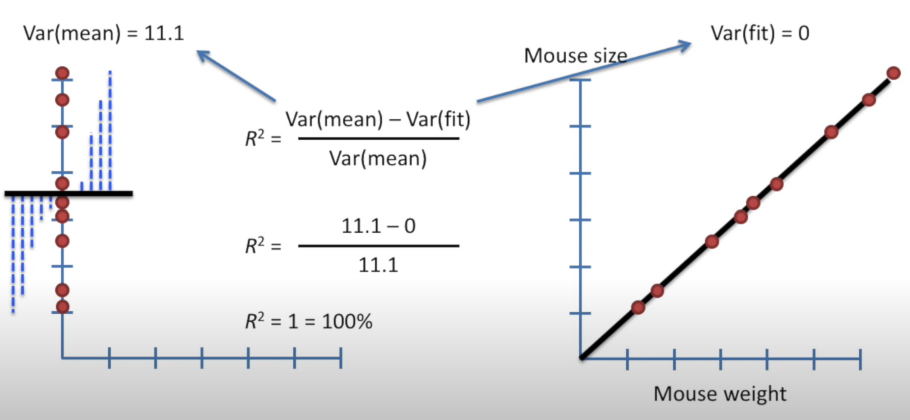

This case, mouse weight explained 100% of variation in mouse size.

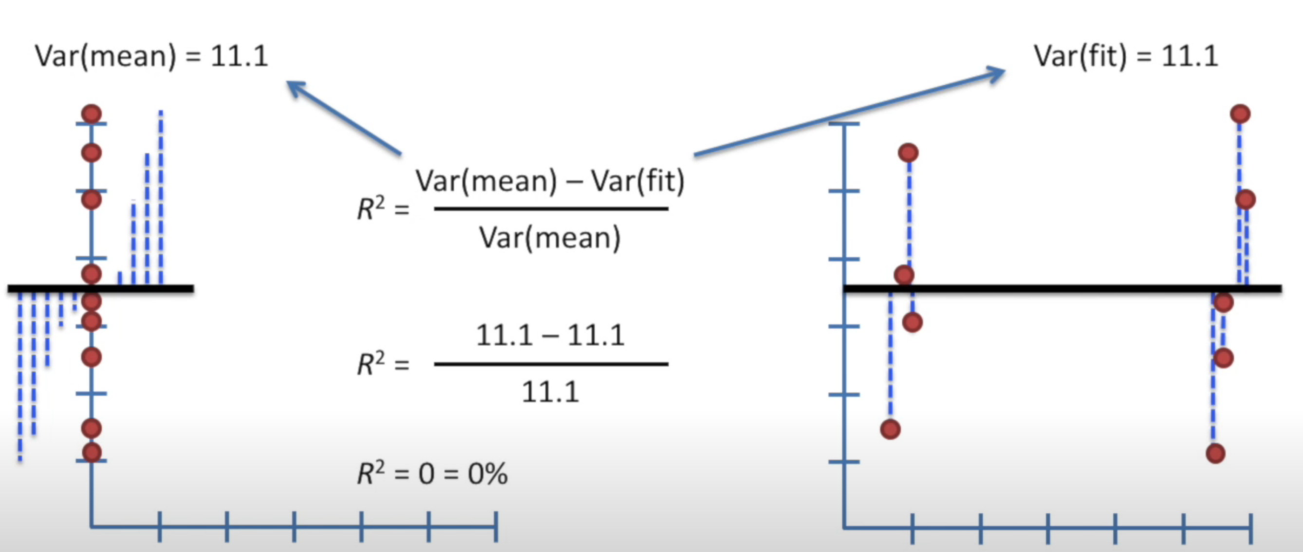

This case, mouse weight doesn’t explained of variation in mouse size.

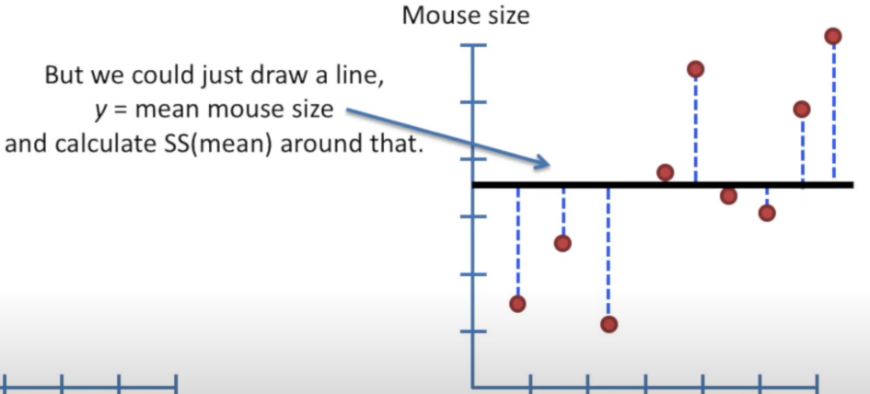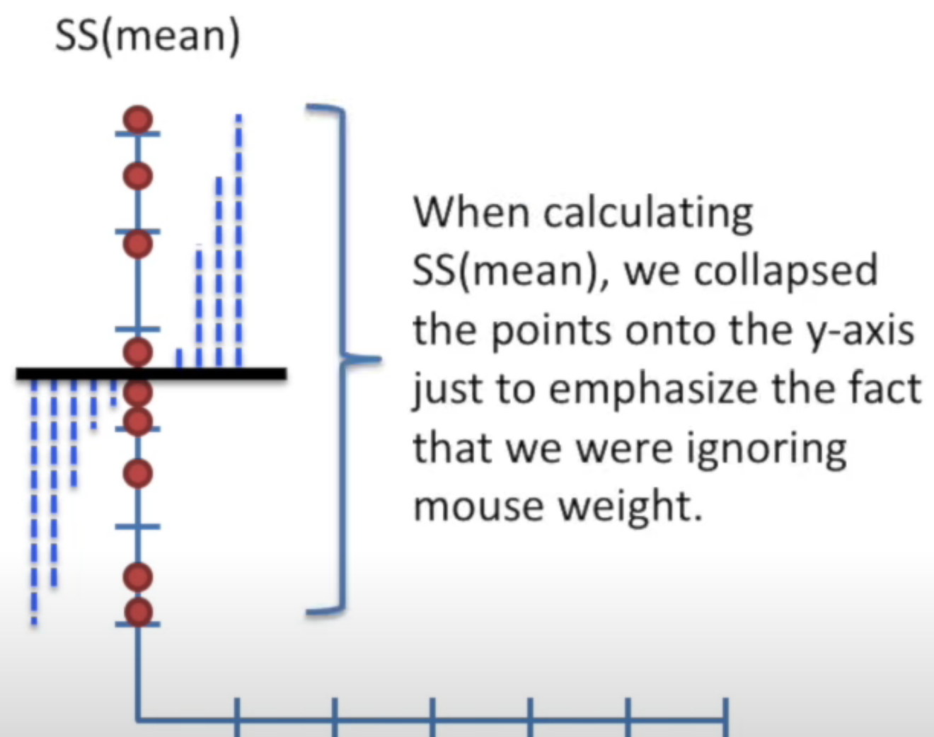

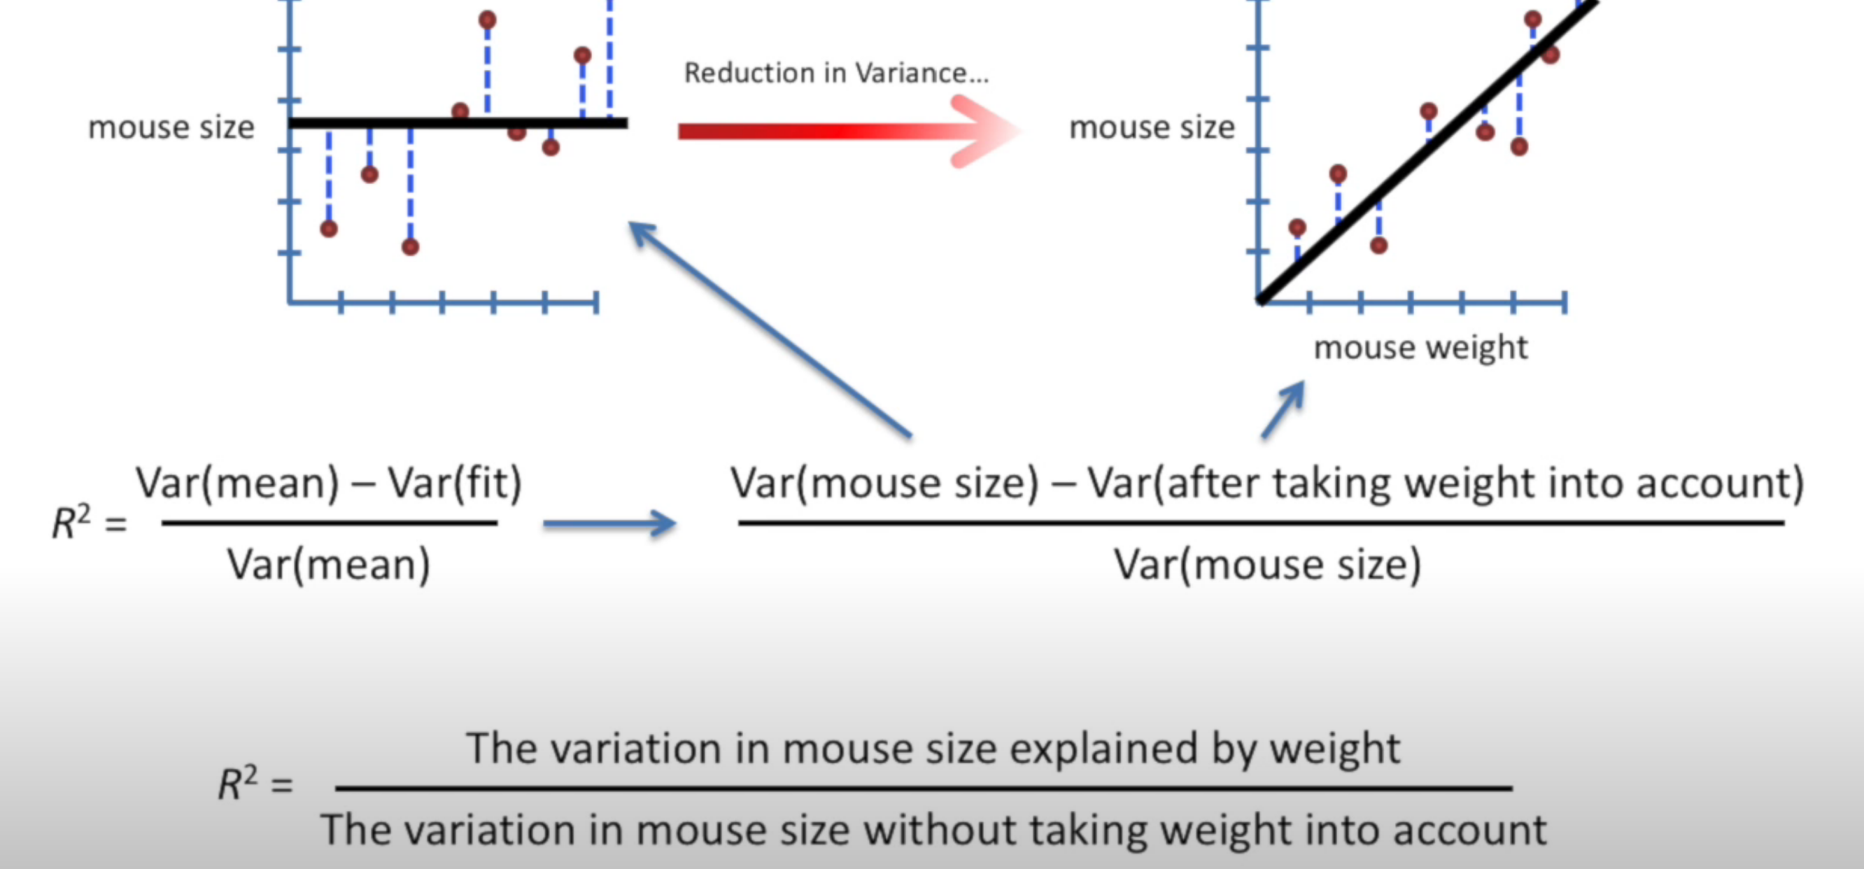

Calculate a p-value for R2.

p-value for R2.come from something called “F”.

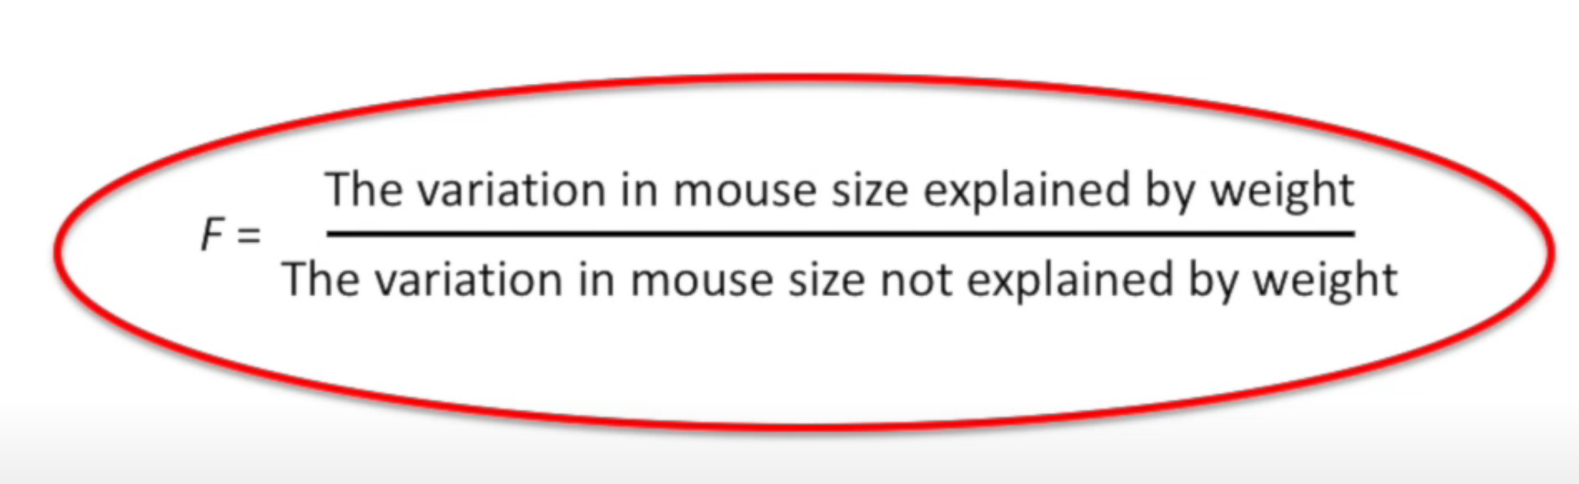

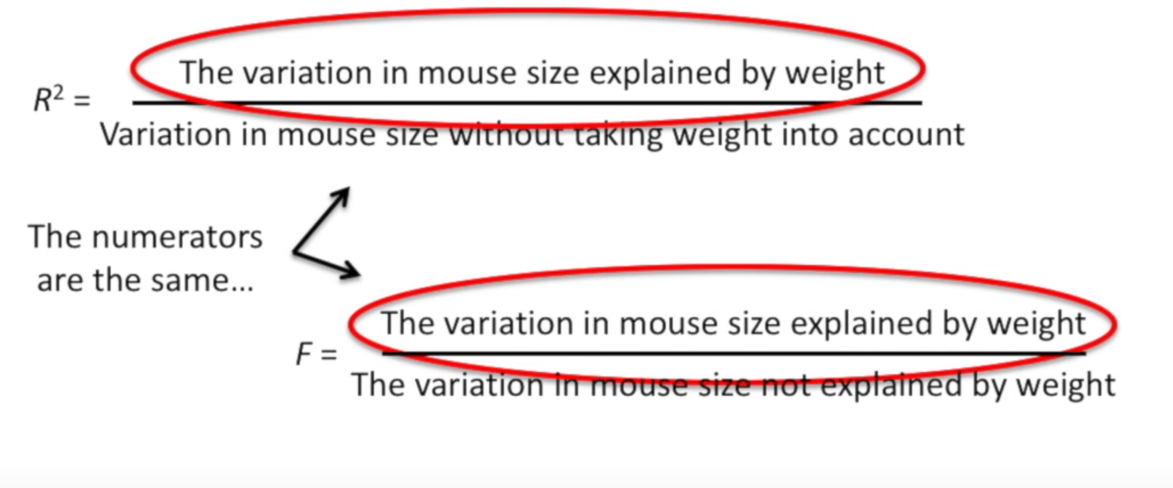

It said: the reduction in variance when we take weight into account.

The denominator is little different

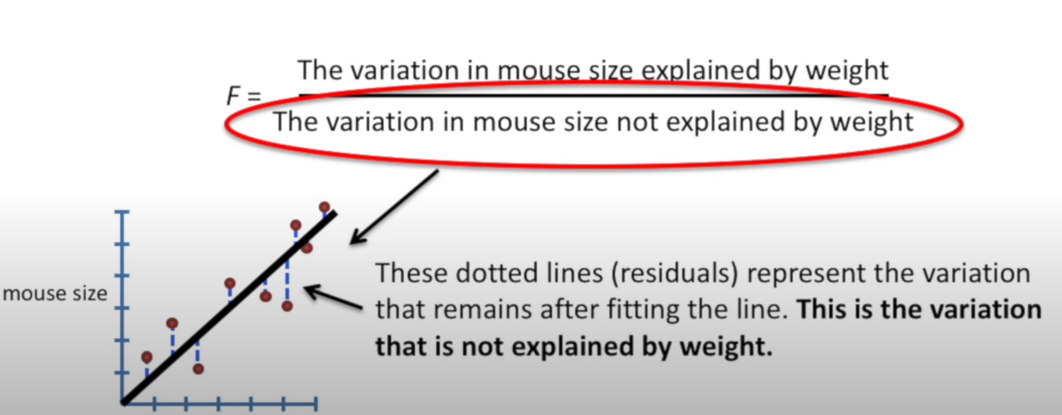

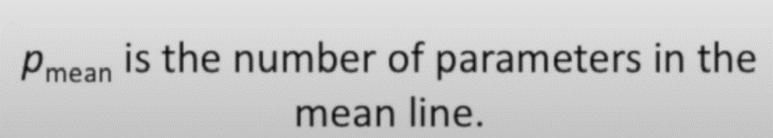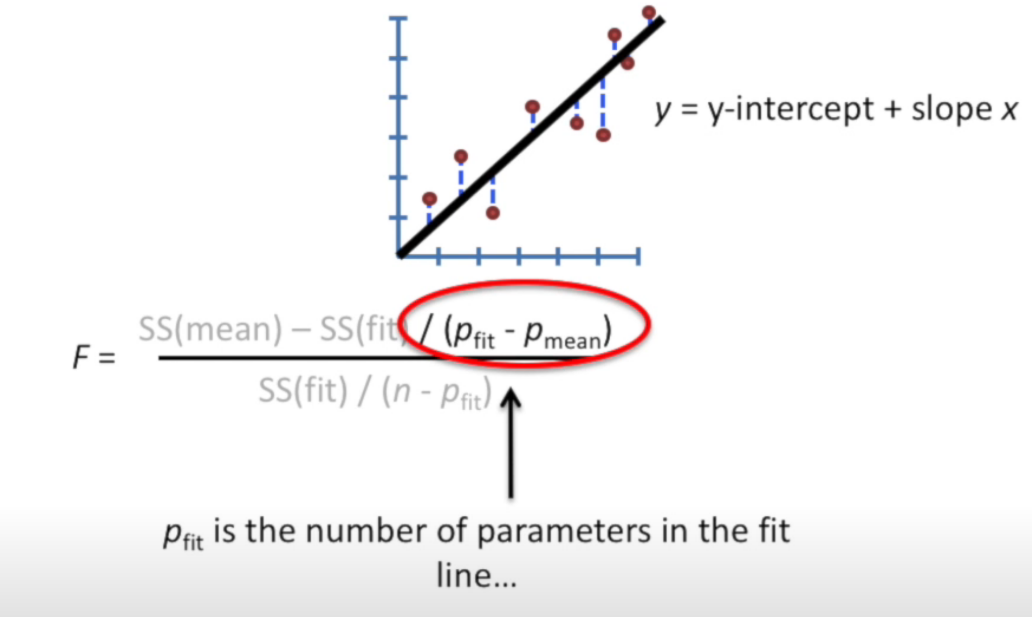

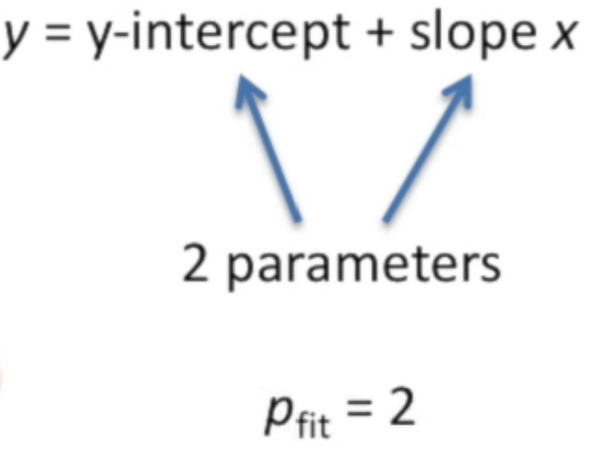

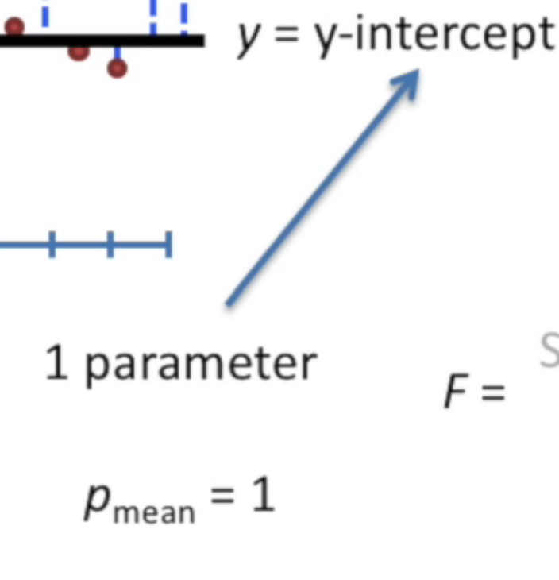

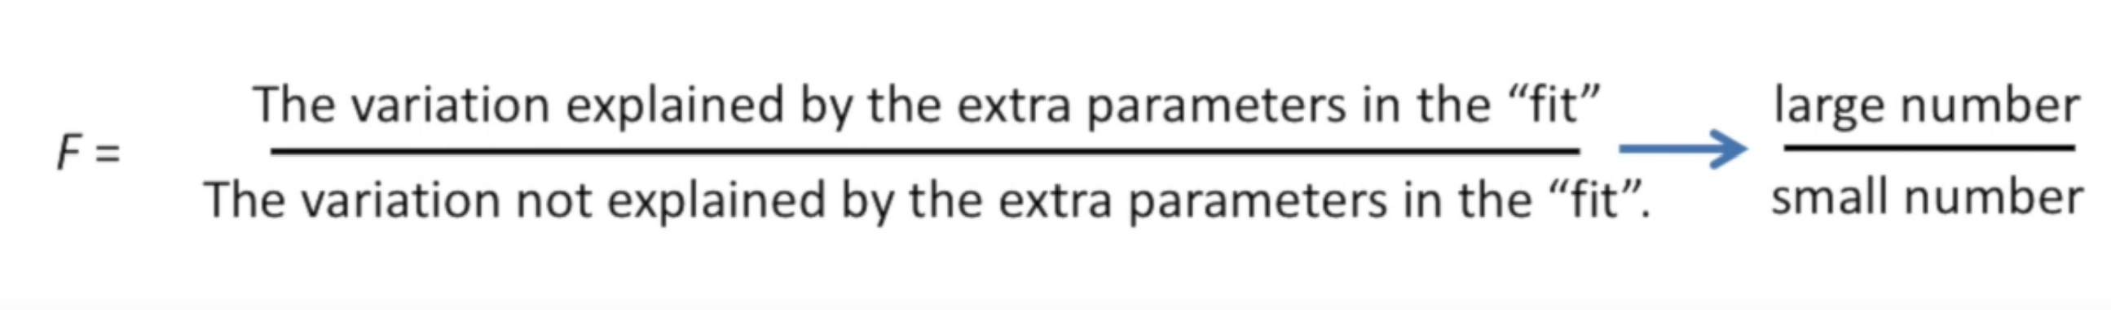

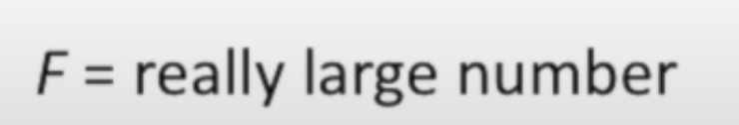

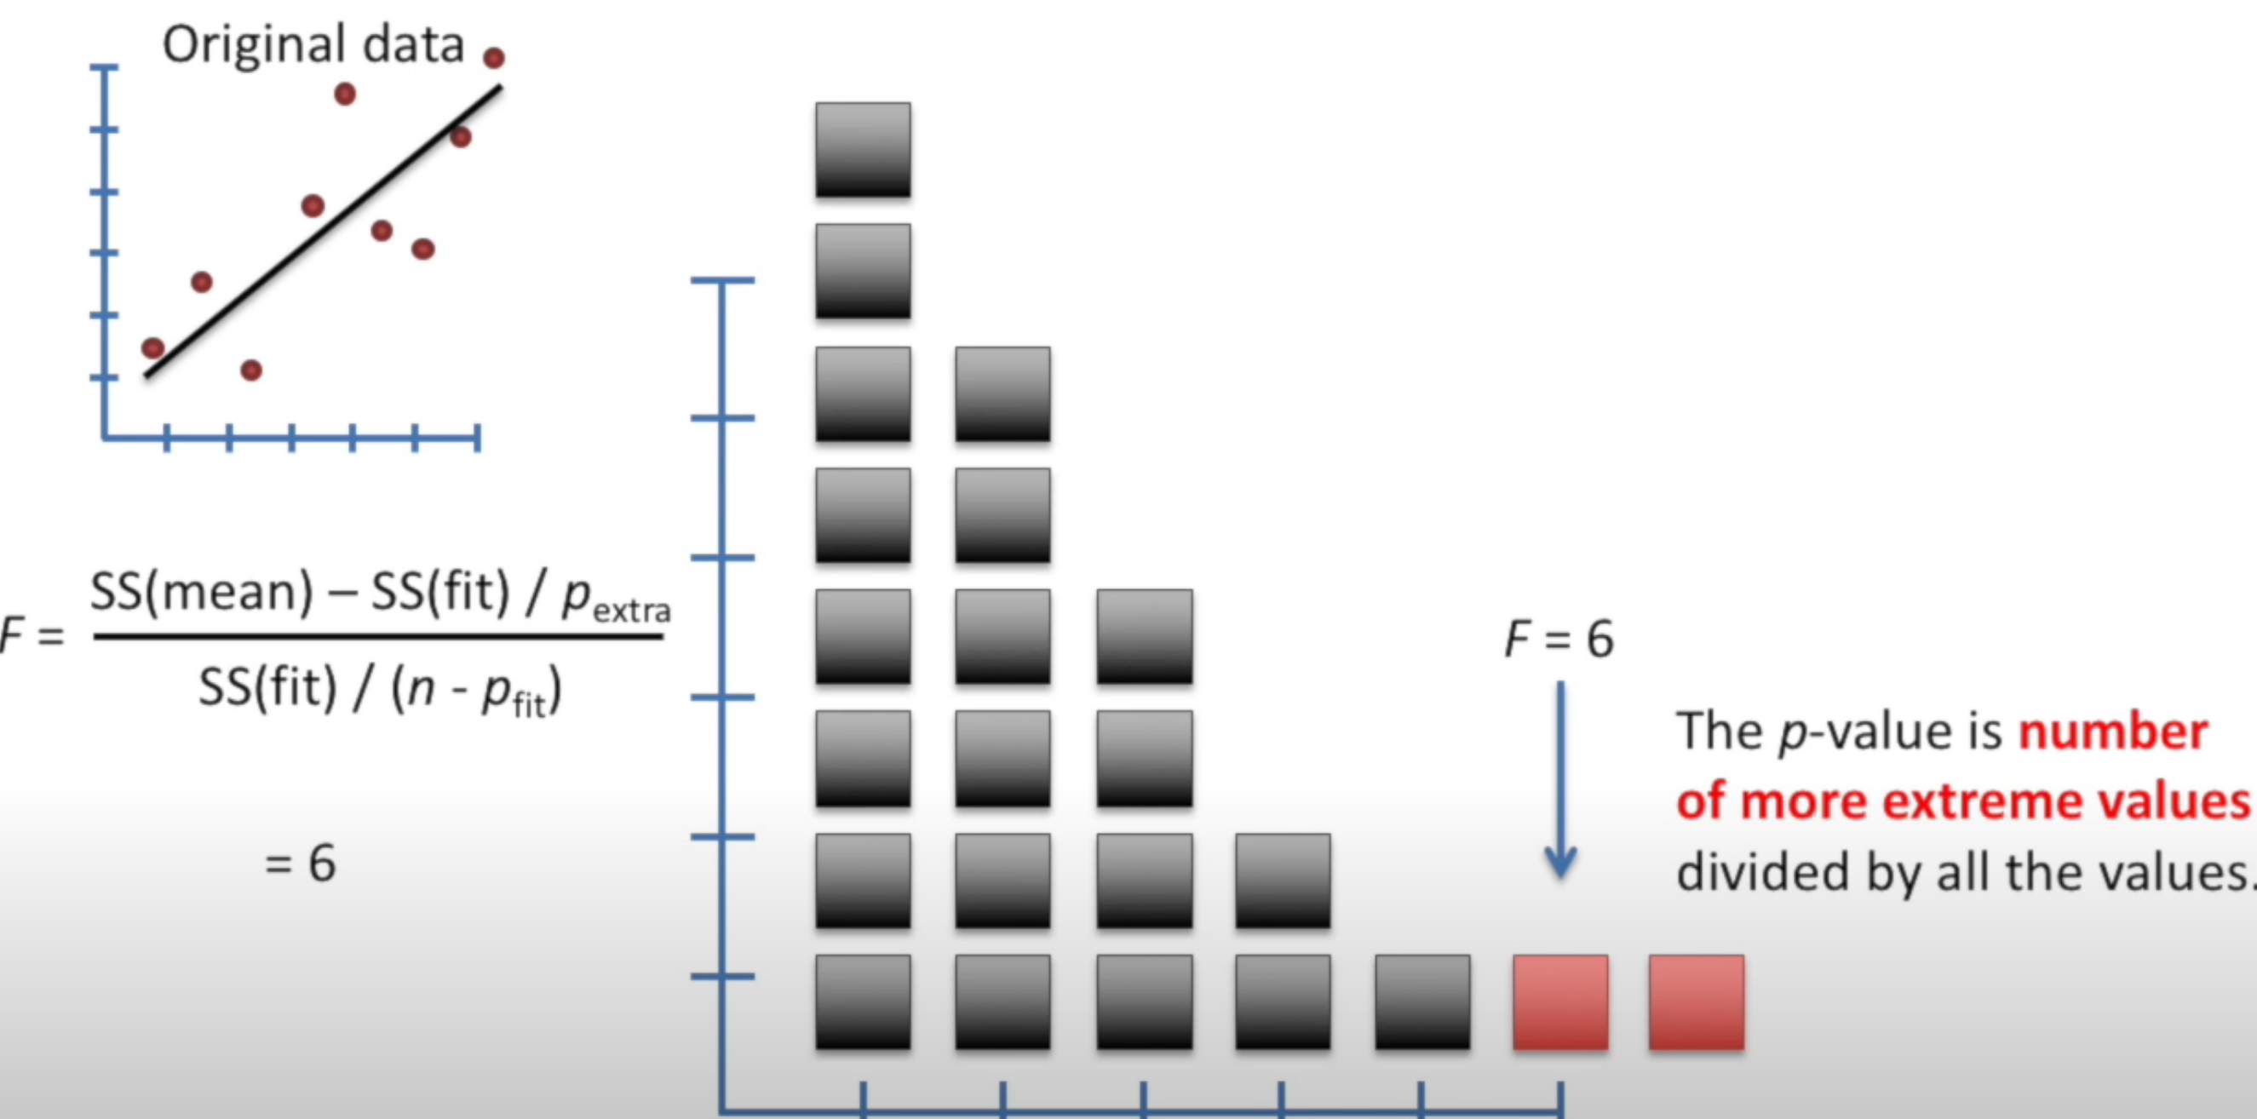

P value is number of more extreme values divided by all the values..

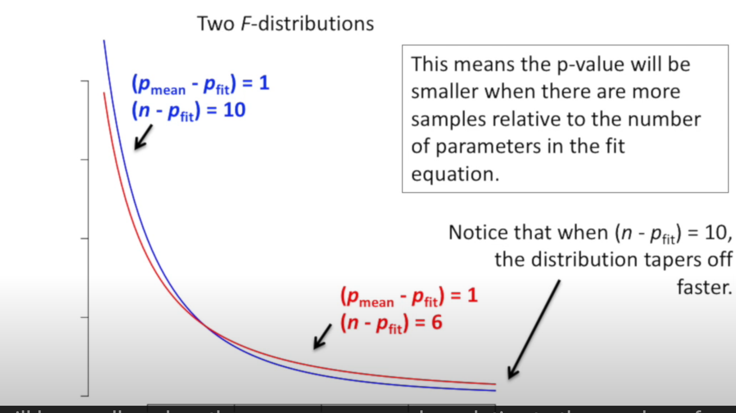

**Gradient Descent**

xsdf